Vote OLIVER LOCKWOOD for MHK on 24th September
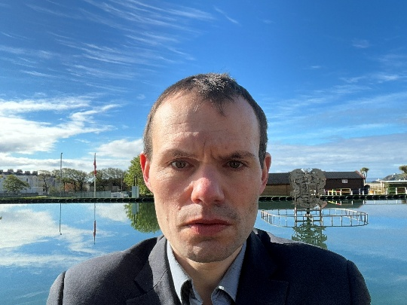
I am an actuary who has developed an approach for making the monthly internal reporting of the financial position of an insurance company to management consistent with the annual reporting in the published accounts. I first became interested in politics due to a desire to bring about such consistency, and hence sound financial management, throughout the economy. As an MHK I would be most closely involved in implementing such an approach within any government departments I serve on, but would also advocate for its adoption more widely.
I have innovative policy ideas in other areas as well, and I describe below what I believe is the most important one within the remit of each government department.
I have served as Lead Member for Finance and General Purposes on the Board of Onchan District Commissioners since May 2025. I have not sought to bring any ideology to the Board, but to ensure it makes well-reasoned decisions and avoids the personal disputes between members that characterised the previous Board.
If I am not elected, then I will believe my life serves no purpose. I will be of the view that my generation will not succeed in achieving the reforms I am calling for and they must be left to the next generation.
Cabinet Office: The Public Health Directorate sits within the Cabinet Office. The Directorate has commissioned several research reports identifying interventions that would improve population health. However, many of these interventions have not been progressed, since there was no means of prioritising them objectively against other policy initiatives. To resolve this issue, I would advocate for the use of health economics to quantify the benefits of public health interventions in economic terms.
Education, Sport and Culture: The education system needs to instil in learners the mindset required for a successful career. I believe the most important part of the mindset learners need to develop is to balance the need to focus on specific tasks with the need to continually reflect on whether their approach is the most effective. Learners should be encouraged to use the breaks in their daily routine as such reflection periods. I believe this principle should be stated in the education curriculum.
Enterprise: The Department for Enterprise is experienced in developing support schemes for businesses satisfying specified criteria. I believe the Department should develop a support scheme for businesses seeking to make their management reporting consistent with their published accounts. The support scheme would also be open to consultancies advising such businesses. This would not only reduce the risk of business failures, but would enable the Island to become a centre of excellence in something I firmly believe will come to be seen as international best practice.
Environment, Food and Agriculture: Delays in the planning system, for which the Department for Environment, Food and Agriculture has operational responsibility, are holding back developments. I believe there is scope to streamline the process by reducing the number of applications referred to the Planning Committee. In particular, I believe applications inconsistent with the land use zoning in the Area Plan for the East should be referred only if the existing use is consistent with the zoning.
Health and Social Care: The Island is an outlier amongst small jurisdictions in retaining a health care system free at the point of use. The system could be placed on a more financially sustainable footing, without forcing anyone requiring medical treatment into poverty, if those with assets or income above a specified threshold were required to contribute to the costs of their own health care. This would enable Manx Care not only to balance its budget but also to expand the range of treatments it offers.
Home Affairs: The behaviour of prisoners is critical to assessing whether they are fit for release on licence. However, currently the Parole Committee has very limited discretion to decide when they are released. I believe there should be a policy aim of maintaining the prison population at a specified level. Objective criteria should be used to identify which prisoners are closest to being fit for release. The role of the Committee should be to ensure that application of those criteria is producing reasonable results.
Infrastructure: The attempt by the previous Infrastructure Minister to introduce 20mph speed limits on most roads in built-up areas on the Island failed because it sought to apply international best practice without regard to the local context. Most main roads in built-up areas on the Island have houses facing directly onto them, and hence serve as both residential roads and through routes. Lowering speed limits on such roads should be done only on a case-by-case basis. However, the anomaly whereby local residential roads not in modern housing estates remain at 30mph should be addressed.
Treasury: Due to repeated failures to increase the personal income tax allowances until the 2026 Budget, some workers earning the minimum wage paid a marginal tax rate of 21% by the 2025-26 tax year, a situation not envisaged when the system was originally designed. To avoid such unintended consequences happening, I believe all allowances and thresholds in the tax system should be increased annually for inflation as a default. Freezing them, without allowing for inflation, should be seen as a policy change.

Contacting me
Email: Oliver.Lockwood.FIA@gmail.com
Facebook: I welcome contact via my Facebook page. I will also be posting on it my answers to questions I receive, so that all constituents can see the responses I provide.
In person at Onchan Library: All day on Saturdays from now until the election.
In person on your road: Please check my Facebook page for dates.
At my home (appointments only please): 66 Main Road, Onchan IM3 1AL

