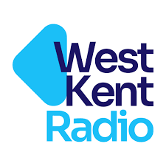
West Kent Community radio – Trustee Nomination form

Proposers should complete Lines 1 and 2 of the Form and forward it to their nominee for consent.

Nominees should complete Line 3 to indicate:

a) their willingness to stand for election as a Trustee
b) confirm that they are not disqualified from acting as a charity trustee (see the Charity Commission’s website at https://www.gov.uk/guidance/automatic-disqualification-rules-for-charity-trustees-and-charity-senior-positions for guidance).

The nominee should forward the completed form as an email attachment to membership@westkentradio.co.uk so that it arrives no later than June 1st 2026
.
Only completed forms submitted by the nominee, not the proposer, will be accepted
1. I wish to nominate:

as a Trustee of West Kent Community Radio

2. Proposer’s name:

3. Nominee’s consent:

Notes:
• Trustees are elected for a period of 3 years at the Annual General Meeting of the Charity.
• The Constitution allows for a maximum of 8 Elected Trustees.
• Both the proposer and the nominee must be fully paid-up members of the Charity at the time of the Annual General Meeting for the nomination to be valid.
• Nominations must arrive by the date specified, which is at least 10 days before the Annual General Meeting. Any nominations arriving after the due date will not be accepted.
• Nominations for elected Trustees will not be accepted from the membership during the annual General Meeting.
• If nominations exceed vacancies, election shall be by secret ballot.

