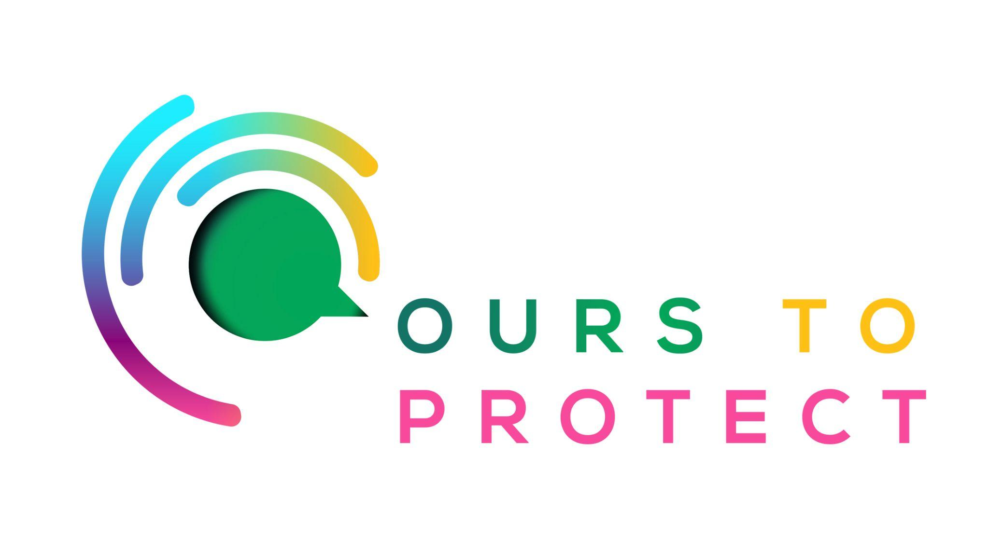

This week Dublin’s Q102 looked at recycling and upcycling with The Upcycle Movement
Did you know…
- This Christmas, it was expected that Ireland would produce 100,000 tonnes of waste.
- According to My Waste, Irish families throw out around €700 worth of food every Christmas.
- Many unwanted items and gifts end up in landfills every Christmas.

What is The Upcycle Movement?
- They rescue and transform materials that otherwise would have gone to landfill. The results are unique and sustainable products.
- Their products are locally made with locally salvaged materials. Environmental consideration is at the forefront of each stage - from source, to design, to materials, to process and packaging.

Here’s a few websites if you want to know more !
The Upcycle Movement
MyWaste Food at Christmas

