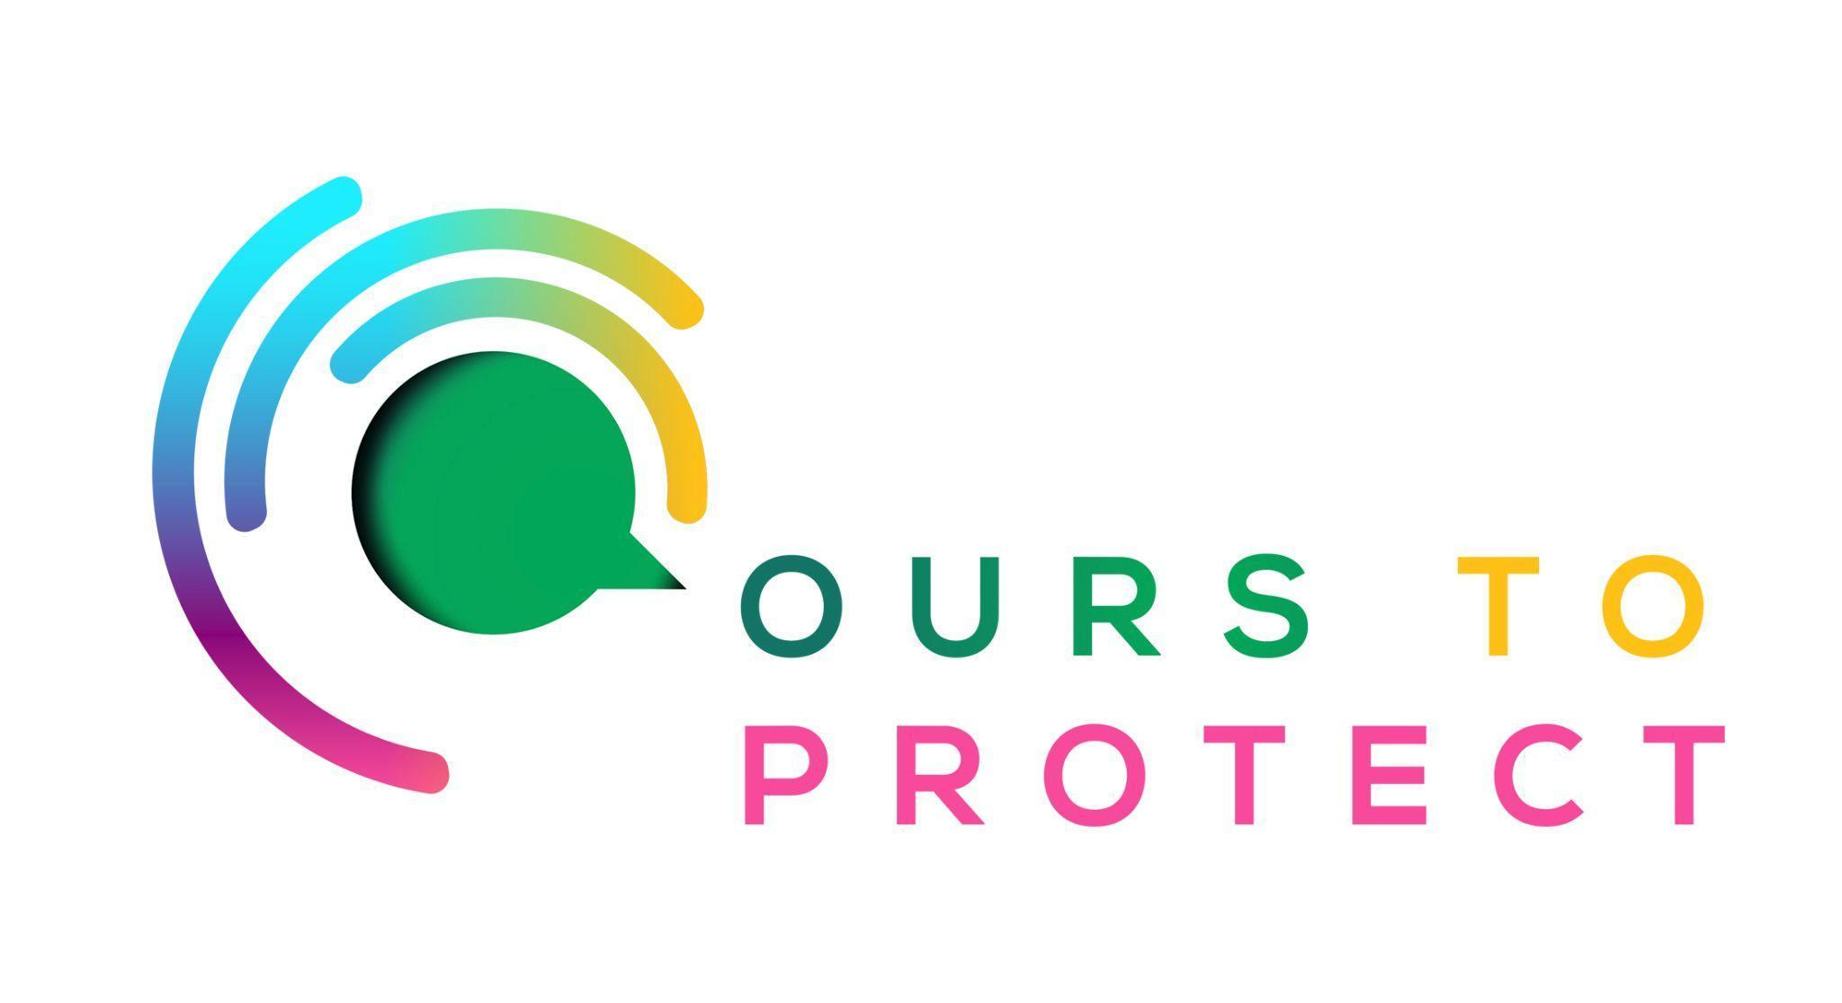

This week Dublin’s Q102 visited a sustainable Christmas Fair in Ballymun
Did you know
- More than 100 million rubbish bags are sent to landfills over the Christmas period
- Globally, the excess waste from packaging, wrapping paper, cards and food increases by 25 to 30% during the holiday season.
What is at the Christmas Fair
- Located at the Rediscovery Centre in Ballymun, dozens of sustainable businesses set up stalls
- From upcycled clothes, lamps and bags, to skincare products and honey, the fair had a wide range of products available.

Here’s a few websites if you want to know more !
Christmas sustainability
Rediscovery Centre

