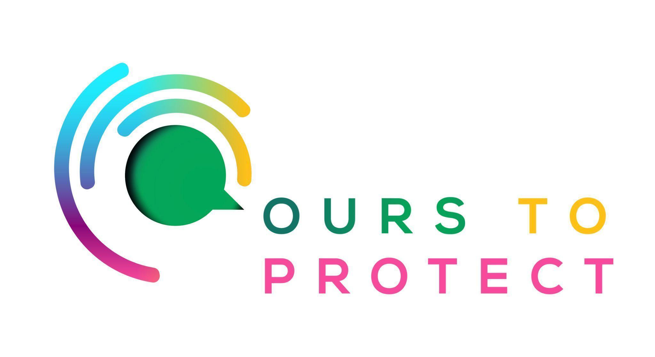

This week Dublin’s Q102 spoke to Elizabeth O’Reilly from WEEE Ireland
Did you know…
- In 2021, a record 71,811 tonnes of electronic waste was collected in Ireland for treatment, the highest quantity ever recorded in the State.
- Ireland surpassed all EU targets for recycling, reuse, and recovery of WEEE in 2021.
What is electronic waste?
- Anything from large household items such aas washing machines and televisions, to smaller items like headphones and disposable vapes are all types of electrical waste.
What can I do to prevent a rise in electrical waste?
- After buying new household appliances, make sure to return your previous item.
- Clear out old electrical appliances from your house.
Here’s a few websites if you want to know more !
WEEE Ireland
E-Waste

