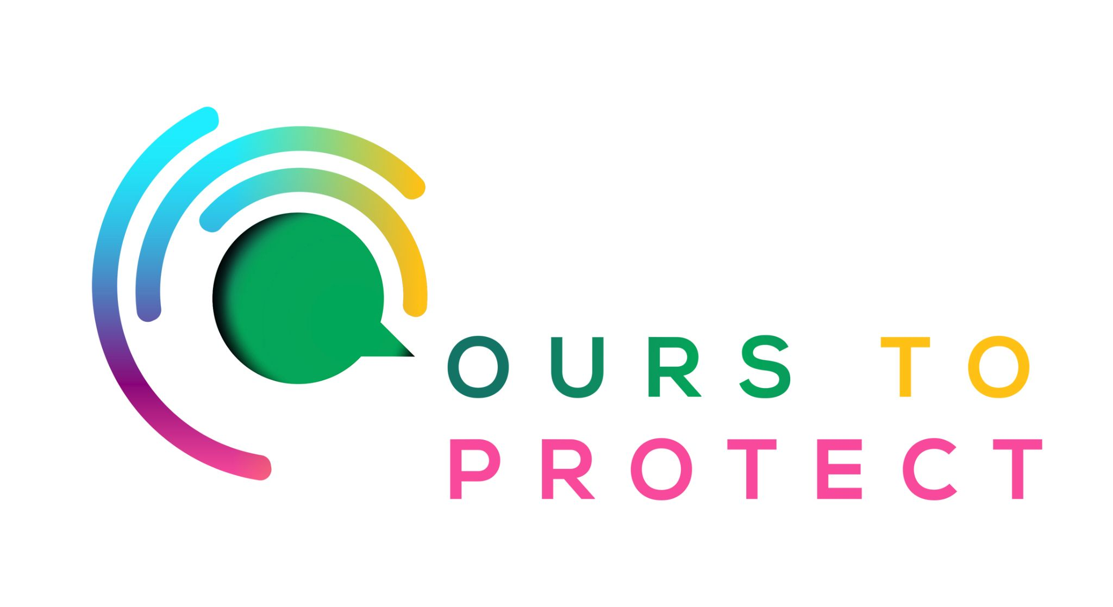

This week Dublin’s Q102 looked Friends of the Earth
Did you know…
- Ireland needs to cut carbon emissions by 50% by 2030.
- To establish a new climate governance regime in Ireland that drives the development and adoption of policies to eliminate emissions in all sectors

Who are Friends of the Earth?
- They are a community at the heart of the growing movement for a world with zero pollution.
- Friends of the Earth wants to build movement power, drive policy change, ensure supporters of the movement that they're supported and continue to develop the organisation.

How can I get involved?
- You can join the movement through their website.
- Sign up for their newsletter
- Sign their petitions that will help drive government action
Here’s a few websites if you want to know more !
Friends of the Earth

