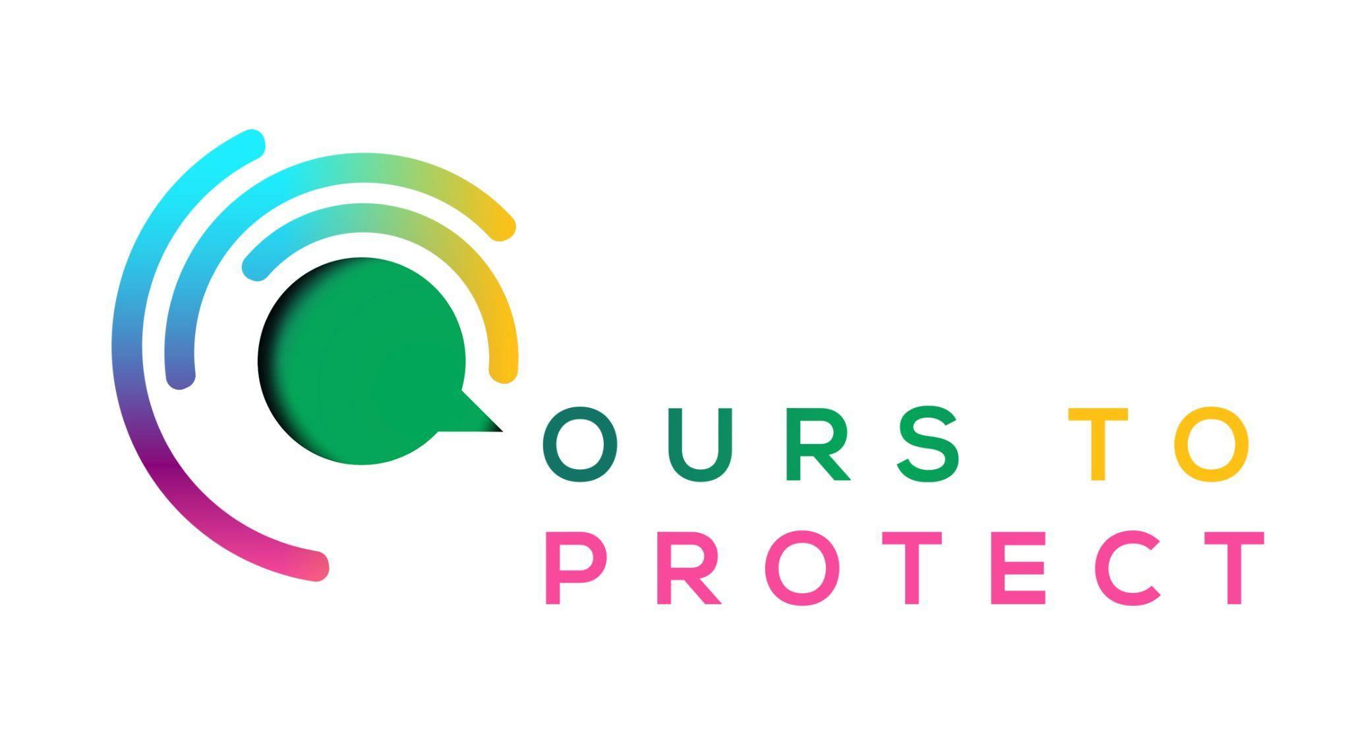

This week Dublin’s Q102 spoke to David Lawlor from Green Ocean Coffee.
Did you know…
- Coffee bean production methods have drastically changed.
- Due to higher demand, farmers have opted for a new technique called the sun-grown technique.
- This destroys the diversity of plants, insects, and animals, and causes a lasting impact on the environment.
What is Green Ocean Coffee
- Green Ocean Coffee is a Dublin based coffee company
- For every 1kg bag of coffee beans they sell, they clean one square metre of sea bed off the Irish coast.

Here’s a few websites if you want to know more !
Allplants
Green Ocean Coffee

