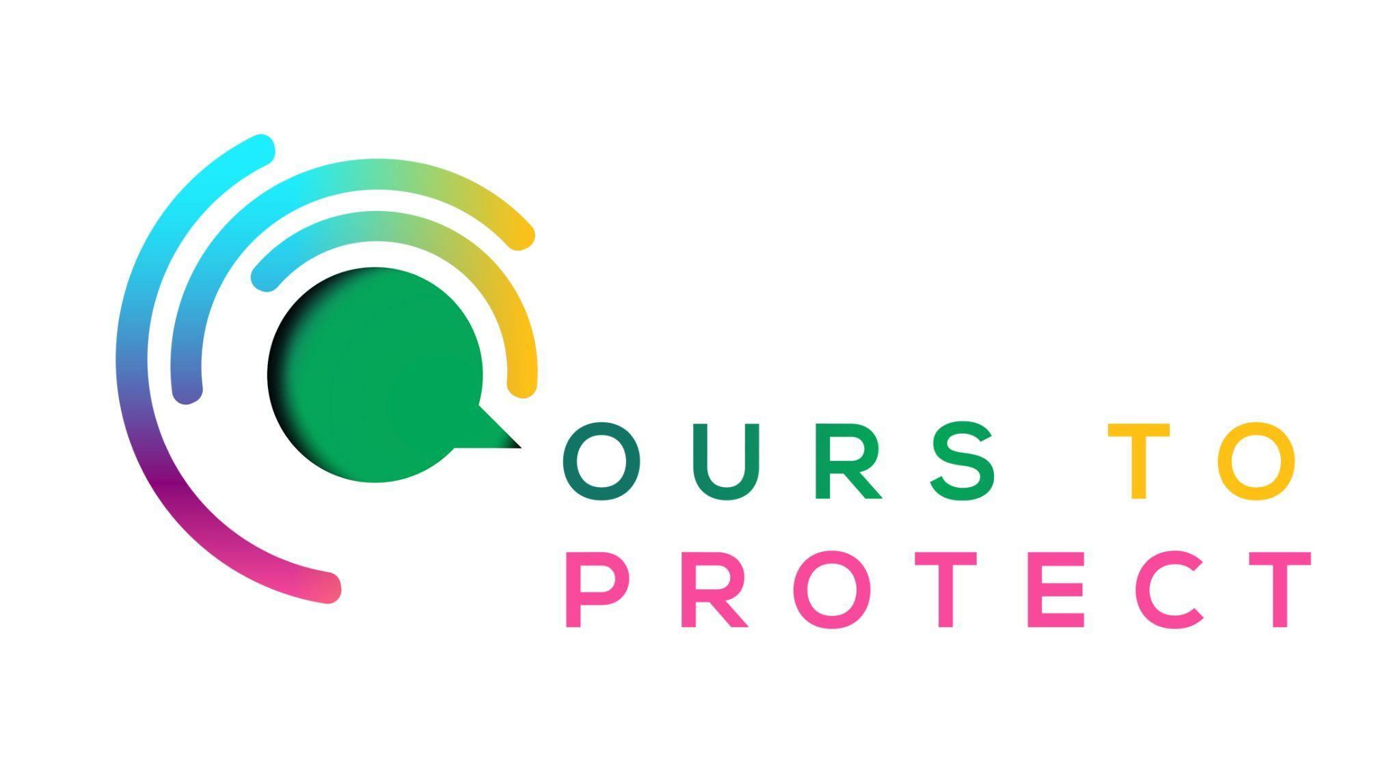

This week Dublin’s Q102 spoke to VOICE Ireland and their role in introducing a deposit return scheme to the country.
Did you know…
- The Return scheme is a refundable deposit that is placed on single use drink containers which will then be refunded to the consumer after returning the items for recycling.
- The scheme is aiming to tackle the estimated one billion plastic bottles and 1.6 million aluminium cans that are believed to end up in landfills or littered across the country.

What do I have to do?
- As customers buy their drinks they will pay an additional charge as a deposit on the items. After returning the used bottles and cans consumers will then be given their additional cost back.

Does anywhere else in the world do this?
- Countries like Norway, Sweden, Finland, and Germany have already introduced a Deposit Return Scheme and it has helped with recycling levels already.
- In these countries, retailers have provided the service to great quality and it is now an expected and normal part of the consumers shopping experience.

Here’s a few websites if you want to know more !
VOICE IRELAND DEPOSIT RETURN SCHEME
deposit return scheme

