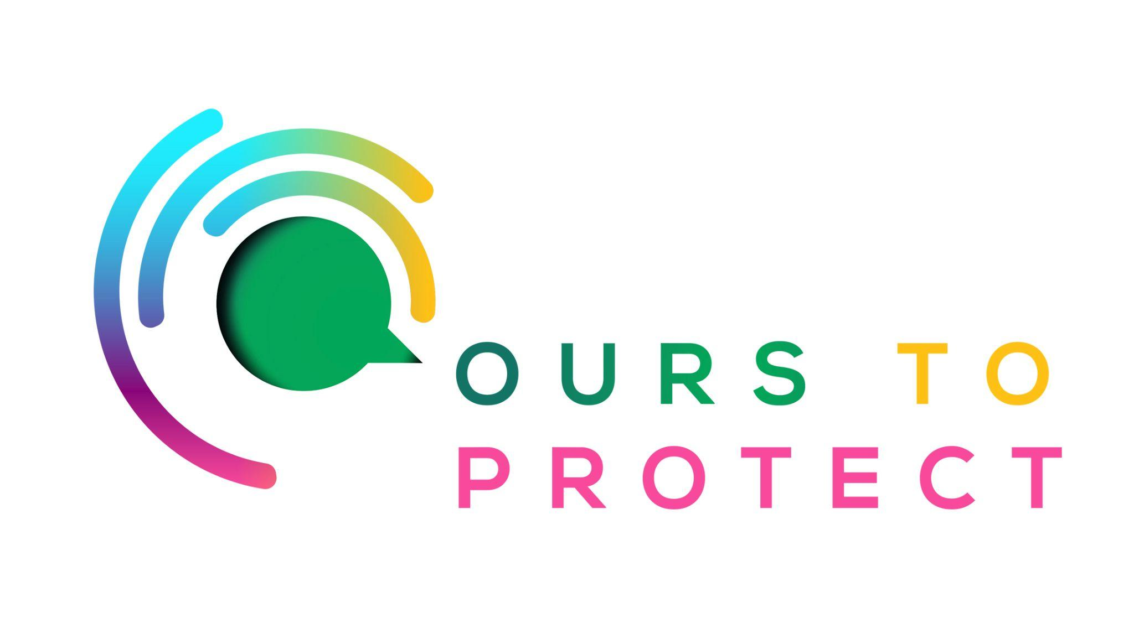

This week Dublin’s Q102 spoke to Owen Keogh, the Head of Sustainability with SuperValu
Did you know…
- Ireland generated a massive 753,000 tonnes of food waste in 2021 according to the Environmental Protection Agency (EPA), of which 29% is from households amounting to a whopping 44kg of food waste per person on an annual basis
- Food waste costs the average Irish household about €700 per year.
- 18% of people don’t know how to recycle food packaging properly

How is SuperValu becoming more sustainable?
- SuperValu is committed to reducing their carbon emissions to be Net Zero carbon by 2040.
- 100% of SuperValu own-brand packaging will be recyclable, reusable or compostable by 2025 .
- In 2022, SuperValu removed over 35 tonnes of plastic packaging while 376 tonnes of non-recyclable black plastic trays across fresh meat and fish changed over to recyclable clear plastic.
- By 2030 SuperValu will reduce food waste in their operations by 50%.

Here’s a few websites if you want to know more !
Global supermarket stats from biofriendlyplanet
Supervalu sustainability

