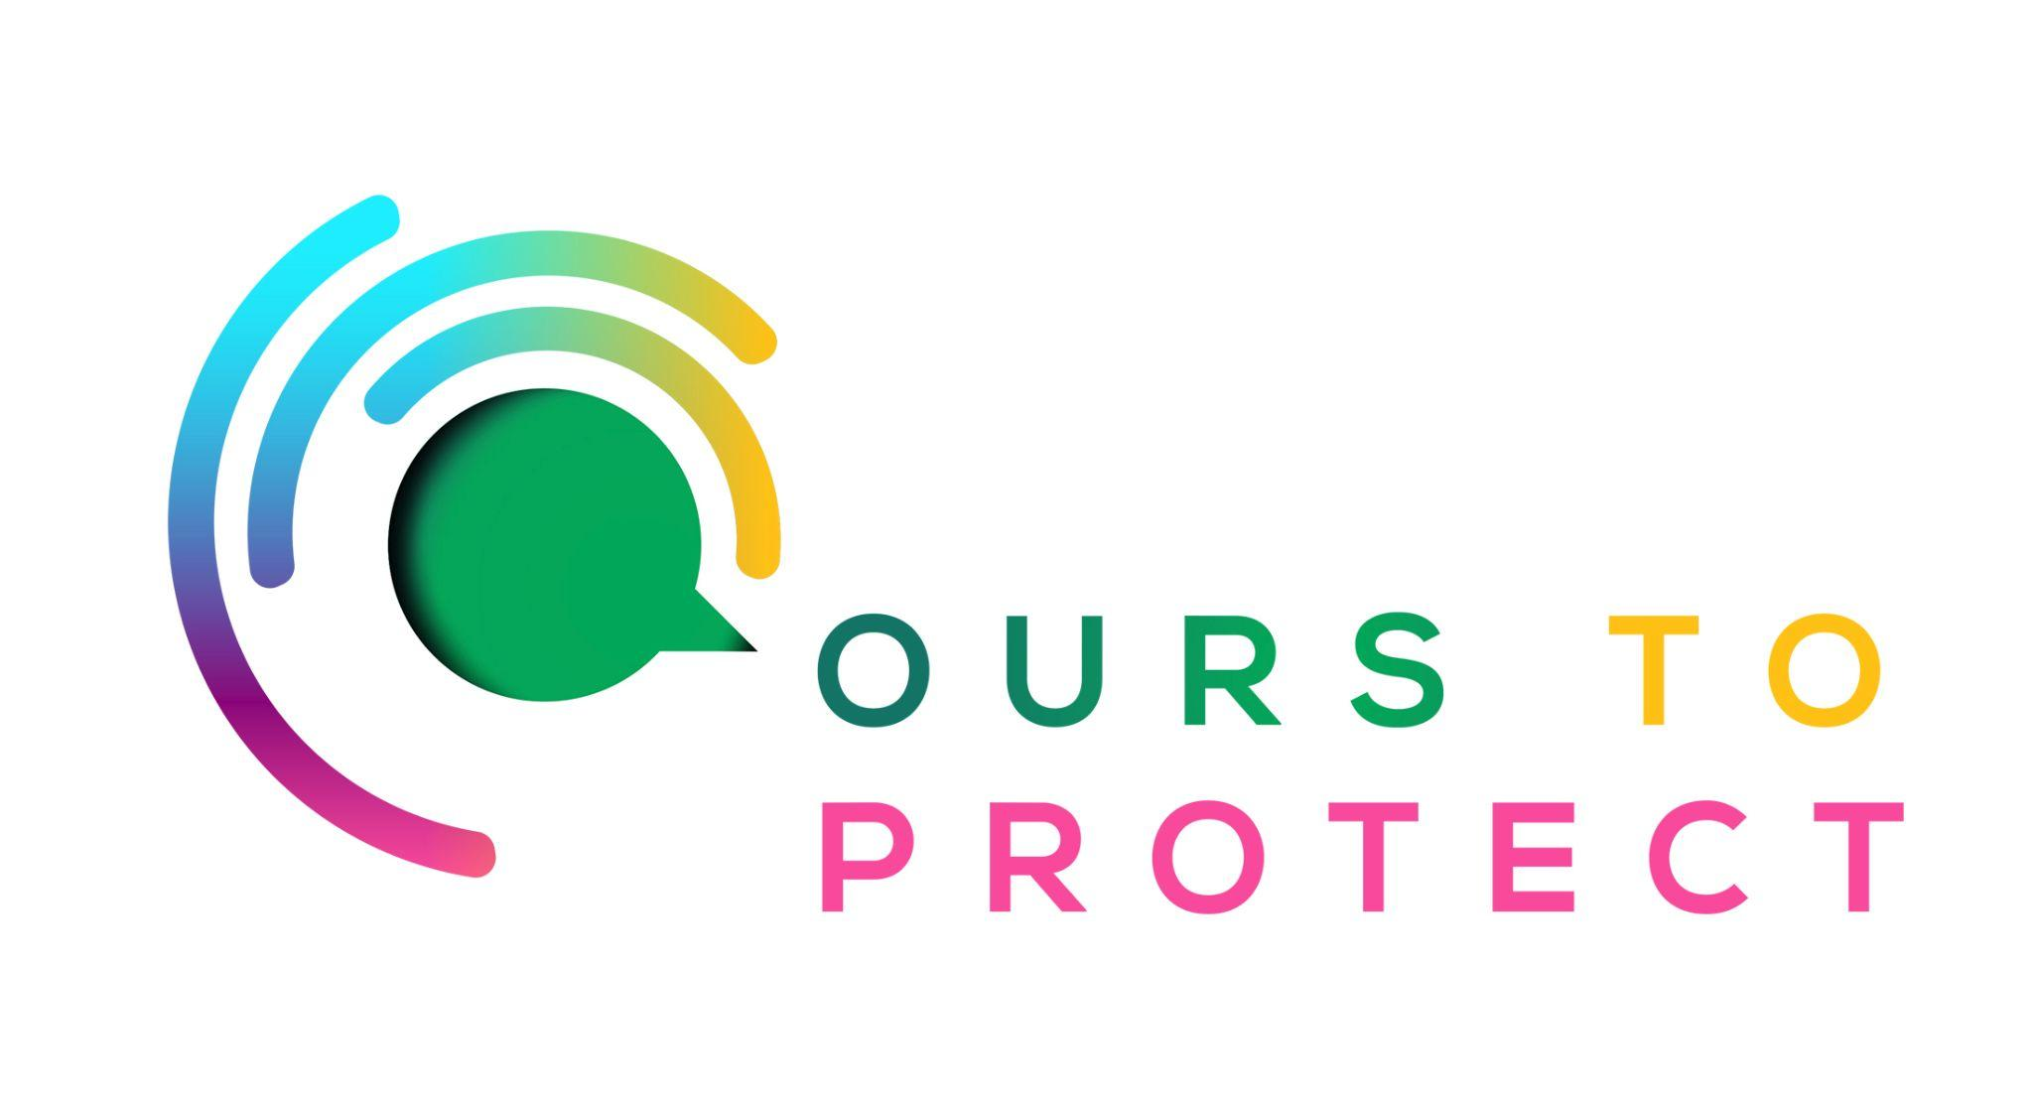

This week Dublin’s Q102 spoke to Voice Ireland about their campaign to ban disposable vapes.
Did you know…
- In the UK, millions of disposable vapes are bought weekly, but less than a thousand can be recycled.
- An estimated 90 tons of lithium and 1,600 tons of copper were used for the global production of
- Single-use vapes in 2022 – the amount needed to produce 11,000 electric vehicles
How are disposable vapes affecting the environment?
- Disposable vapes contain vital materials like lithium ion batteries and copper that are vital to the production of electric cars.
- Lithium demand will soar by 35 times by 2050 with incoming legislation that ban the sales of new combustion engine vehicles by 2035.
- An estimated 90 tons of lithium and 1,600 tons of copper were used for the global production of single-use vapes in 2022 – the amount needed to produce 11,000 electric vehicles.
How can I help stop the pollution caused by disposable vapes?
- Voice Ireland and Minister of State Ossian Smyth are calling on the public to sign a petition to ban the use and sale of disposable vapes.
- If you buy these vapes, don’t litter or throw on the sides of the street.
Here’s a few websites if you want to know more !
Vaping in Ireland
Ban Disposable Vapes Ireland

