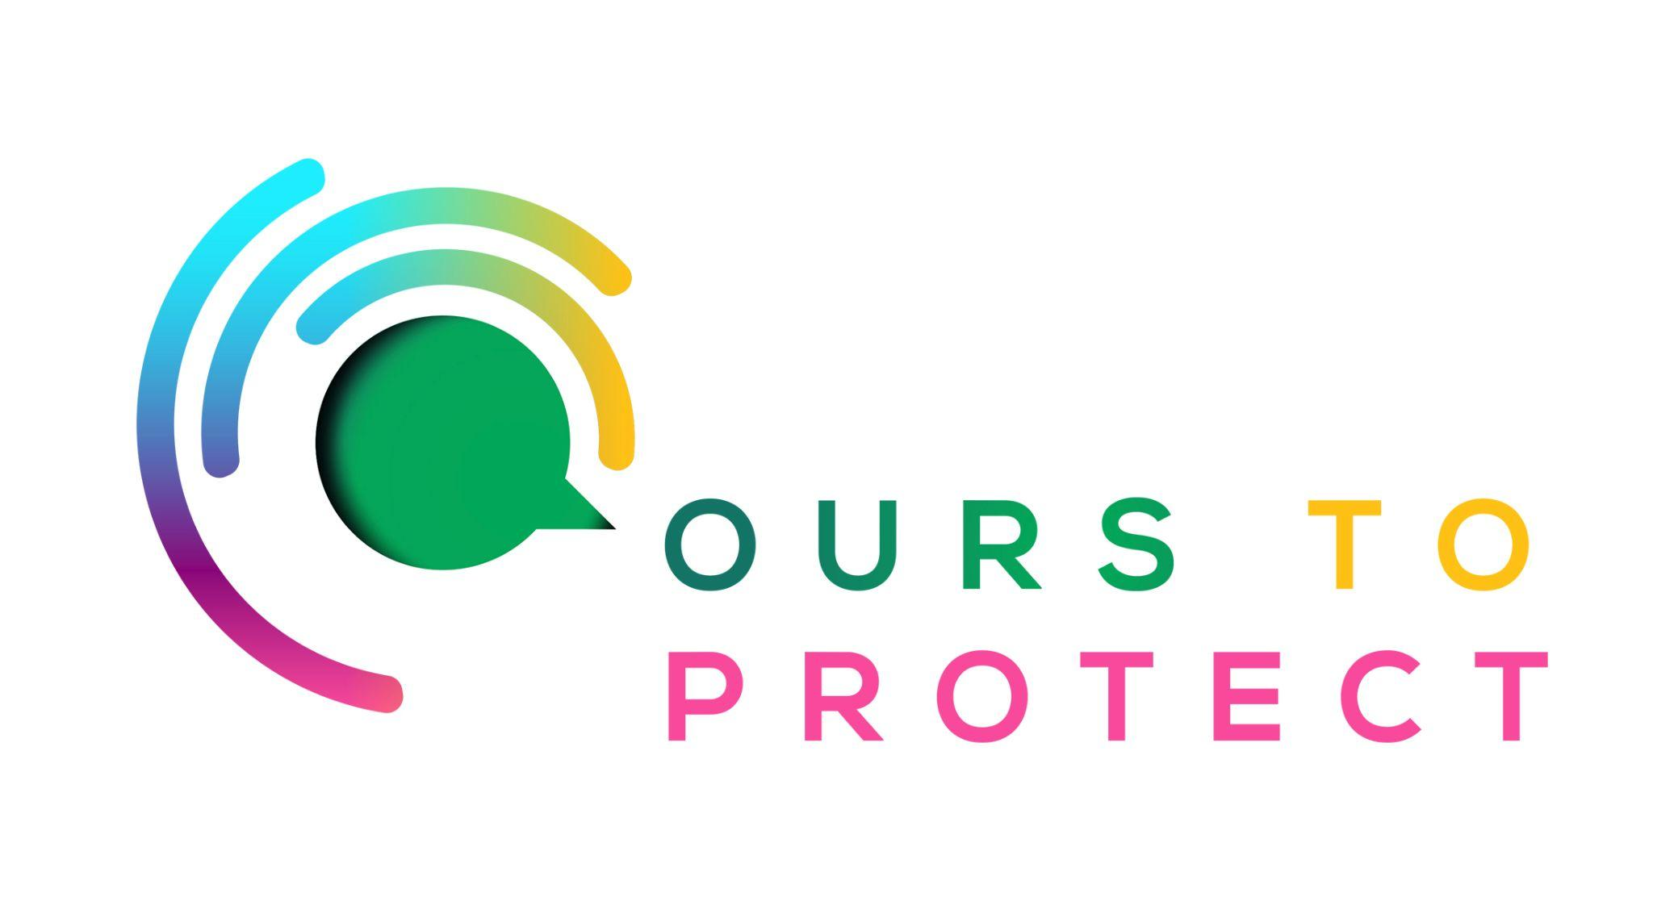

This week Dublin’s Q102 looked at Too Good To Go.
Did you know…
- Food waste contributes to around 10% of global greenhouse gas emissions.
- When food decomposes, it releases a potent gas called methane.
- The average Irish household wastes around €700 on food.
- The food industry is responsible for more than 189,000 tonnes of food waste in Ireland.

What is Too Good To Go?
- Too Good To Go is a mobile app specialising in connecting customers with unsold goods and food from restaurants, shops and more.
- Instead of restaurants throwing away perfectly good unsold food at the end of the day, you can buy a surprise bag of items for around 30% of the original price.

How can I help with food waste?
- Use a compost bin.
- Only buy necessary items while shopping.
- Use the Too Good To Go app to help in the fight against food waste.
Here’s a few websites if you want to know more !
Too Good To Go
Environmental Protection Agency Food Waste
Food Waste Ireland

