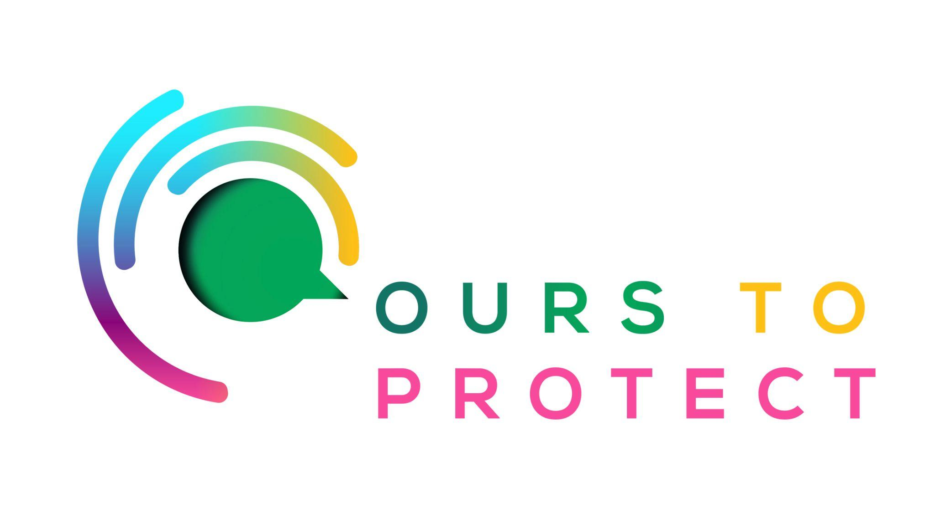

This week Dublin’s Q102 looked at the impact of climate change on Irish wildlife and biodiversity.
Did you know…
- Some native Irish species are at risk of extinction, including the Red Squirrel and the Natterjack Toad and the Atlantic Salmon.
- Wolves roamed around Irish mountains and forests until the late 1700s.
- Ireland used to be home to brown bears, lynx, grey whales and the Irish elk.

What is causing biodiversity loss in Ireland?
- Irish land and marine ecosystems currently absorb around half of human caused CO2 emissions.
- Many species cannot adapt to changing temperatures by moving across our highly modifed landscapes.
- Agricultural practices can negatively impact biodiversity. The expansion of monoculture farming, the use of pesticides and fertilizers have all had an impact on Irish wildlife and biodiversity.
- Overfishing can lead to declines in fish populations.

How can I help preserve Irish wildlife and biodiversity?
- Support conservation companies like the Irish Wildlife Trust
- Educate yourself on all species habitats and the threats that they face.
- Consider introducing a wildlife friendly garden
Here’s a few websites if you want to know more !
Irish Wildlife Trust
Irish Biodiversity

