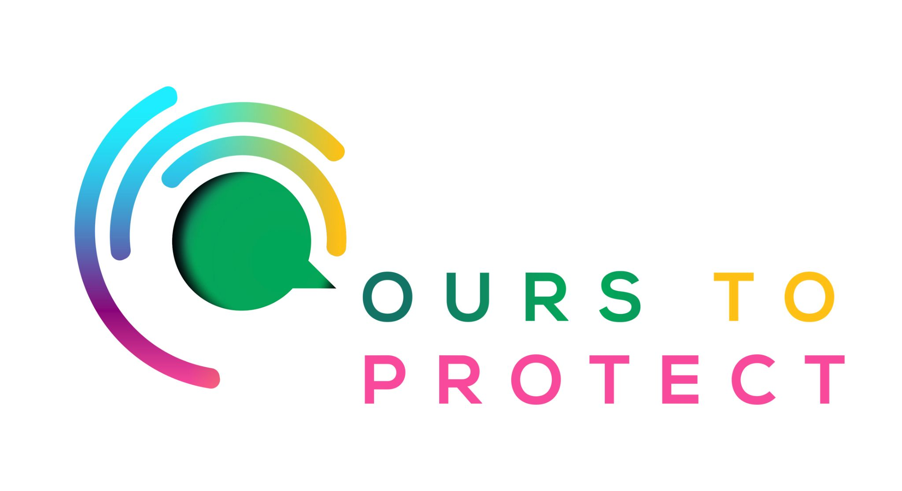

This week Dublin’s Q102 looked at Picker Pals and littering in Ireland
Did you know…
- 54% of all litter in Ireland is cigarette butts.
- In 2019, the National Litter Pollution Monitoring System reported that pedestrians caused the highest level of litter pollution at 41%.
- When litter breaks down, it releases toxic gases and chemicals that make its way into the air, soil and waterways.
What is Picker Pals?
- Picker Pals is primary school programme inspiring and equipping children to become the next generation of environmentalists

How can I help keep my community free of litter?
- Dispose of your waste correctly.
- Volunteer with clean-up groups or Tidy Town committees
- Make sure your area is clean by heading out on a litter picking adventure
Here’s a few websites if you want to know more !
Picker Pals
Ireland litter picking

