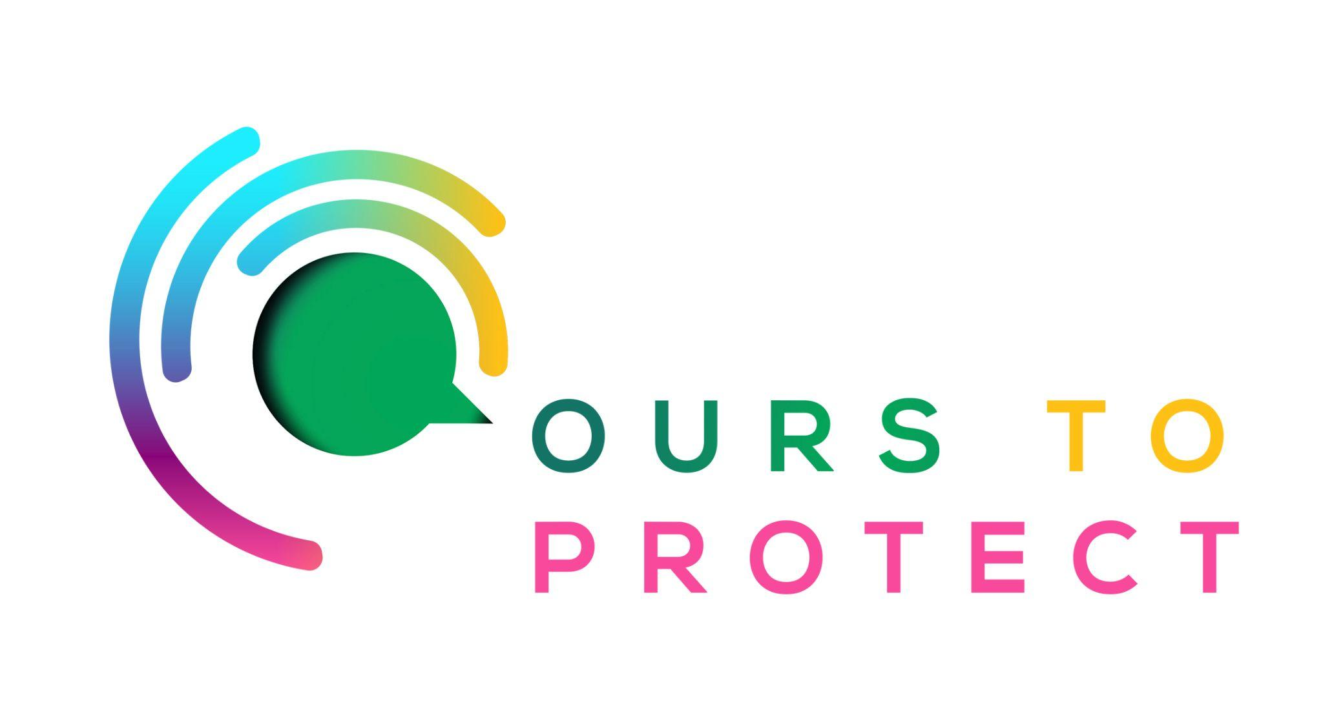

This week Dublin’s Q102 spoke to Harriett and Flossie Donnelly, founders of Flossie and the Beach Cleaners, an environmental and marine charity.
Did you know…
- UN Climate Change say that the ocean has long taken the brunt of the impacts of human-made global warming
- By the end of the 21st century, global sea level is expected to rise by 0.5m on average
- Rising sea levels have the potential to inundate freshwater ecosystems and affect the quality of groundwaters.

Who will be affected?
- The changes to our seas are causing a lasting impact on marine biodiversity.
- The 680 million people living in low lying coastal areas.
- Nearly 2 billion people live in some of the world's largest coastal cities
- Almost half the world's population that rely on fish for food.

What can I do to help with rising sea levels and pollution in the oceans?
- Don’t leave litter in rivers, oceans or on beaches.
- Consider joining a beach cleaning community like Flossie and the Beach Cleaners.
Here’s a few websites if you want to know more !
Flossie and the Beach Cleaners
Impact of climate change on our oceans
Irish seas and coastal impact

