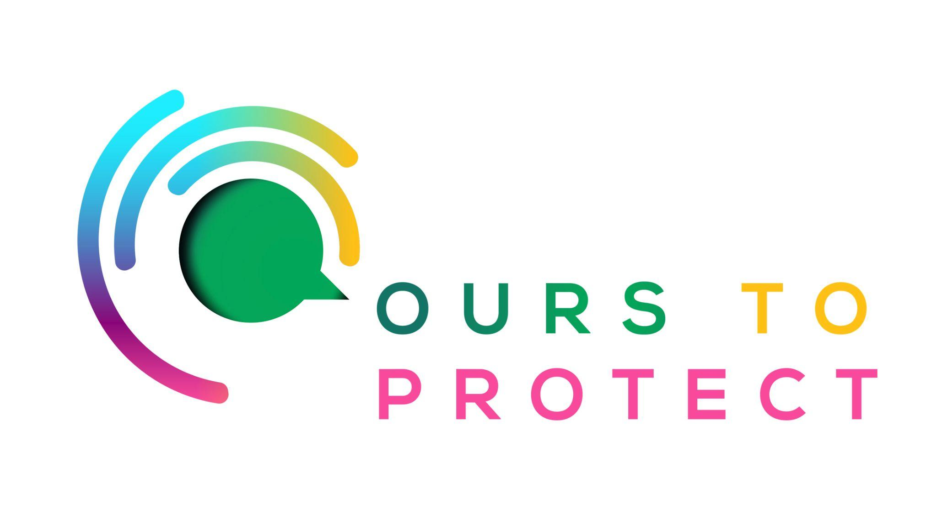

This week Dublin’s Q102 spoke to environmentalist Duncan Stewart about Ireland’s impact on climate change.
Did you know…
- Duncan Stewart was awarded the Freedom of Dublin award alongside Great Thunberg in June.
- He was the first environmentalist to receive the award.
- Ireland is not on track to reach its 2030 Climate Action Plan targets.
Ireland’s Climate Targets
- According to the Environmental Protection Agency, Ireland will achieve a reduction of 29% in Greenhouse Gas emissions by 2030 compared to a target of 51%.
- The first two carbon budgets will not be met.
- Emissions from transport are projected to reduce by 35% over the period 2021 to 2030 if the measures set out in plans and policies are implemented.
How can I help Ireland reach our Climate Action Plan targets?
- Try to reduce your individual waste, like water, food.
- Opt for public transport where possible.
- Consider your impact on the climate before travelling on long journeys.
- Buy from more sustainable fashion brands rather than fast fashion outlets.
Here’s a few websites if you want to know more !
Ireland’s Climate Action Goals
2023 Climate Action Plan

