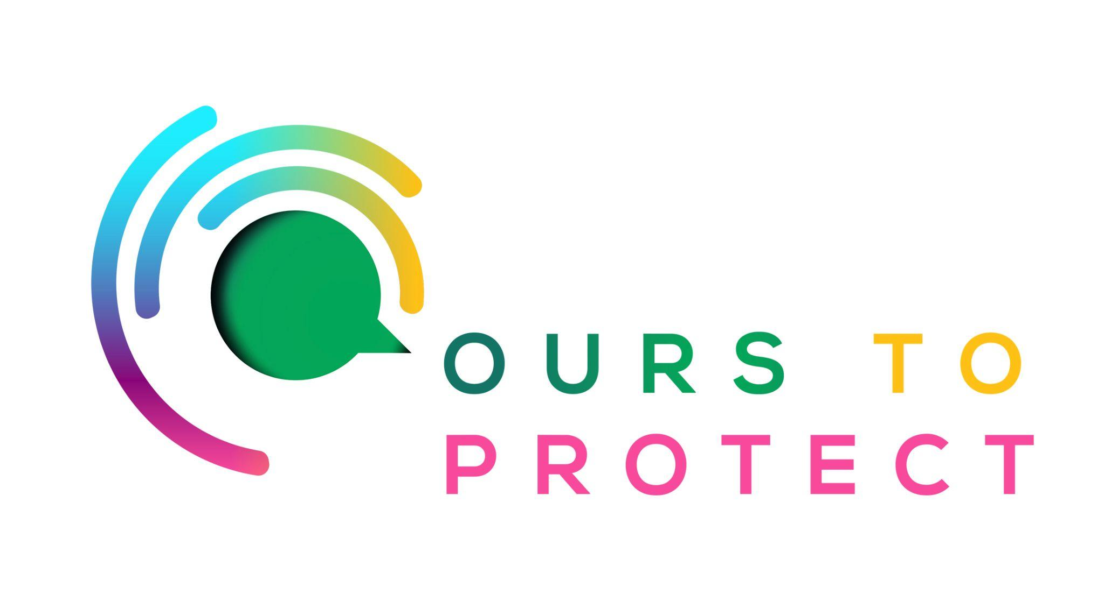

This week Dublin’s Q102 looked at Sustainable Fashion and the impact Fast Fashion has on the environment
Did you know…
- According to the UN Environment Programme, the fashion industry is the second biggest consumer of water
- The fashion industry is responsible for around 10% of global carbon emissions.
- Penneys is aiming to make all of their clothes fully sustainable by the year 2030.
What is Fast Fashion?
- Fast fashion involves the rapid design, production, distribution and marketing of clothing where much of the items will end up in landfills after only being worn a handful of times.
What can I do to help with fast fashion
- Support local sustainable fashion outlets
- Consider shopping on depop where you can often find good quality, second hand clothes.
- Think about wearing and keeping clothes for years rather than months and not buying a specific outfit for every occasion.
Here’s a few websites if you want to know more !
Fresh Cuts Clothing Dublin
What is sustainable fashion?
The dangers of fast fashion

