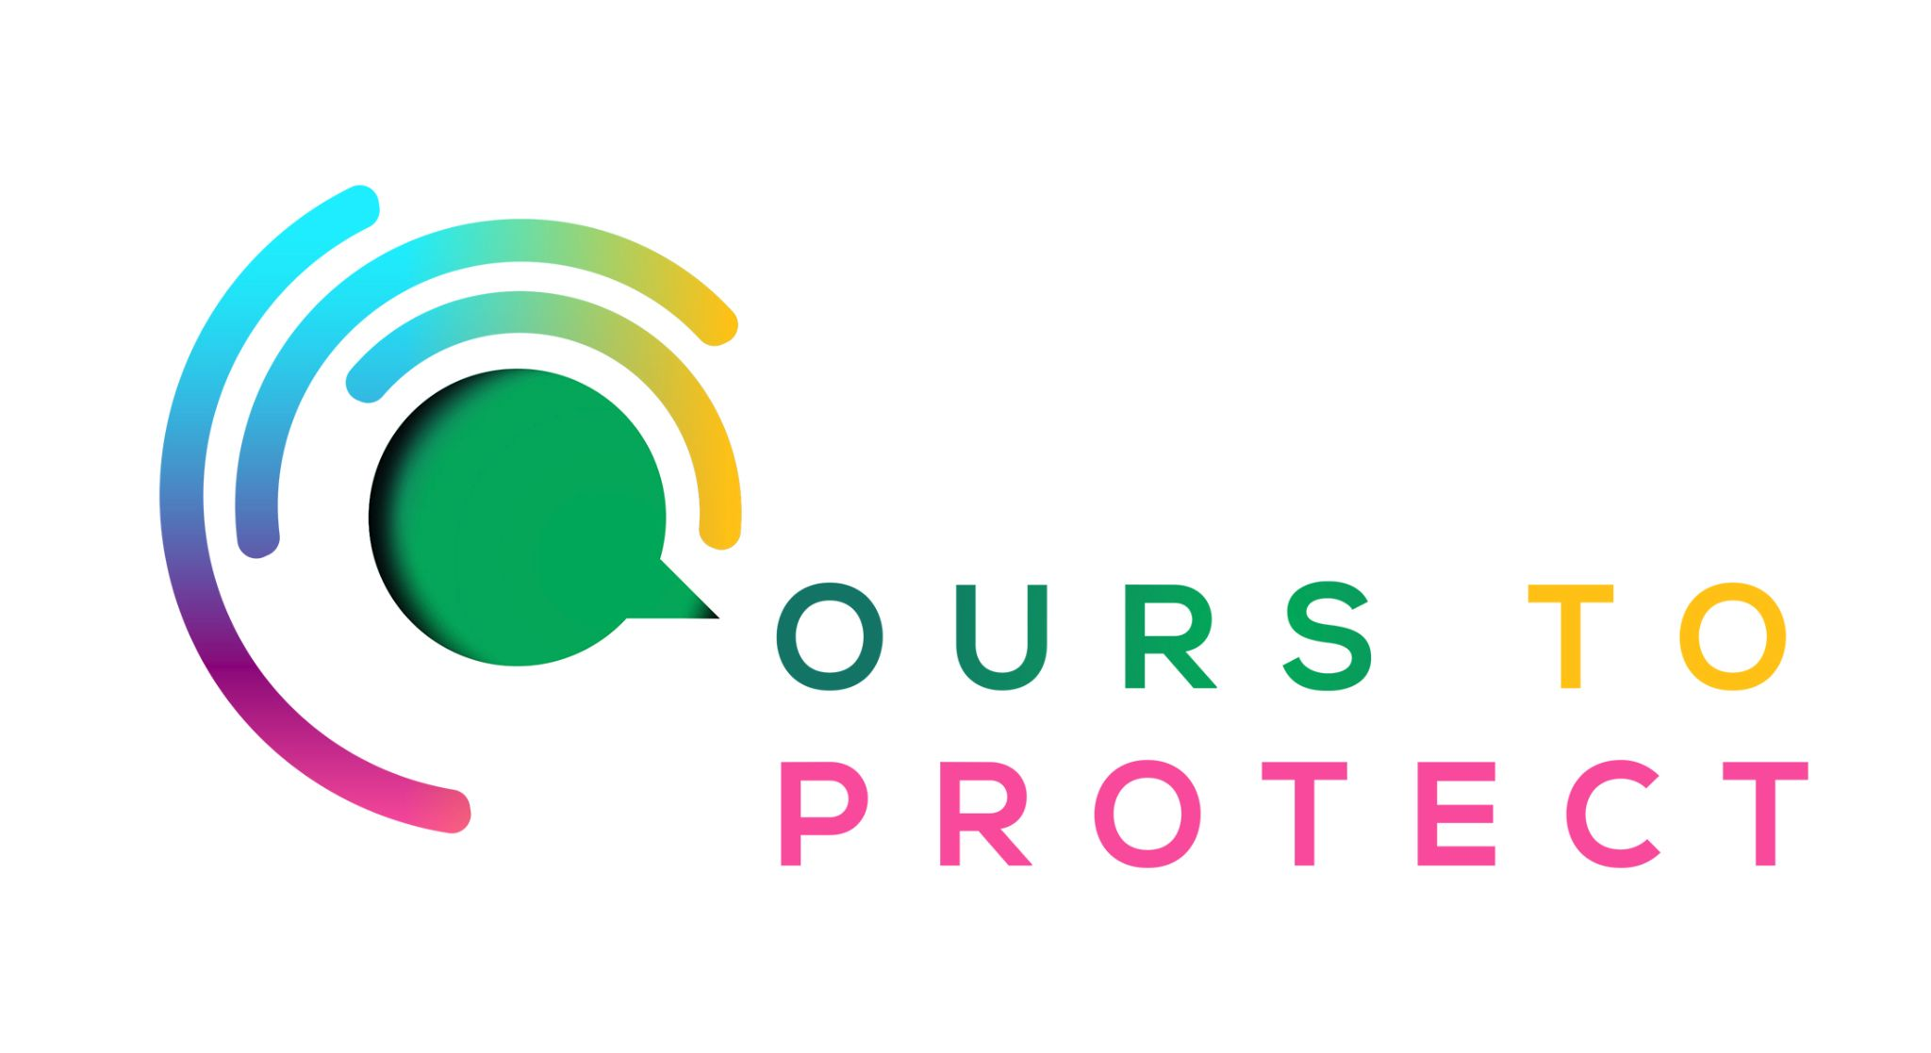

This week Dublin’s Q102 looked at Greenwashing in the Aviation and Travel industry
Did you know…
- 16 million people departed Ireland by air in 2022.
- 3.7 million left Ireland by air during the first quarter of this year, a 1.5 million rise compared to last year.
- Most airlines offer customers the chance to offset their carbon emissions after booking their flights.
What is Greenwashing?
- Greenwashing is a term used to describe untrue or misleading facts made by companies or industries about the positive impact the company or service has on the environment.
- Greenwashing isn’t always a completely false or untrue claim, it can also be a claim that isn’t entirely accurate and can be seen as deceptive.
What can I do to help with carbon emissions while travelling?
- Travel more sustainable routes and consider the impact that long haul flights can have on the environment.
- Travel more sustainably and consider opting for holidays around Ireland rather than abroad.
Here’s a few websites if you want to know more !
Fáilte Ireland's Plans To Drive Sustainable Tourism
The Truth About Flying and Greenwashing

