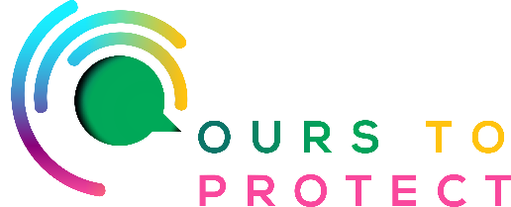

This week on Ireland’s Classic Hits Radio we’re looking at how best to start growing your own vegetables.

Growing Your Own Food vs. Buying It From the Store
Growing your own food is honestly life-changing. If you haven’t tried it yet, what’s holding you back? You can grow so many delicious things in your own garden, or even on a balcony. Once you start growing your own food, the benefits will be hard to ignore. Edible gardening is a hobby that’s definitely worth exploring—you’ll gain so much in the process!
Here’s why we think you should start growing your own food in 2024.

1. It Saves Money

2. It’s Convenient

3. It’s Healthier

4. You’ll Know Exactly How It Was Cultivated

5. It’s Better for the Environment

6. You’ll Be More Self-Sufficient

7. It’s an Opportunity to Try New Foods

8. It Supports Local Pollinators

9. It Gets Young Kids Interested in Vegetables

10. It Makes Your Garden Prettier

For more information:

www.betterplants.ie

www.growveg.com/guides/5-great-reasons-to-grow-your-own-food

