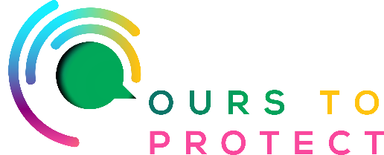

This week on Ireland’s Classic Hits Radio we’re looking at the concept of Conscious Consumerism.

What is Conscious Consumerism?:
Conscious consumerism is the practice of mindfully and intentionally buying and using products as a statement of values. The opposite of conscious consumption is mindless consumption.

5 things you should know about Conscious Consumerism

1. Conscious consumerism is on the rise
Some 56% of Europeans consider themselves to be conscious consumers and 67% have bought products that were better for the environment despite being more expensive, research by PayPal has found.

2. The modern-day consumer seeks to consume mindfully
Conscious consumers avoid ‘mindless consumption’ and seek out greener products with longevity.
Post-pandemic, consumers are more aware of how and where they’re spending their money and aim to reduce plastic waste.

3. Demand is surging for locally sourced products
Sustainability-minded consumers will check where the product ingredients come from and how they’re processed before buying. It’s important to them that this information is available online and at every step in the purchase cycle.

4. Retailers who do the right thing are favoured
With 84% of consumers rating brand trust highly when choosing a product, according to IBM, it’s important for conscious consumers to choose brands with values like their own and seek to build trust with businesses.

5. Mindful consumption drives ethical offerings
If you want to appeal to conscious consumers, incorporate sustainability into your products and processes.

For more information:

www.theearthymarketplace.com

www.growensemble.com/conscious-consumerism

