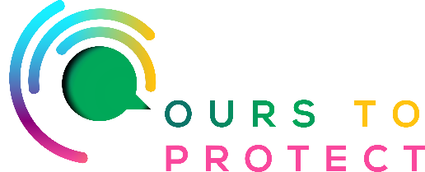

This week on Ireland’s Classic Hits Radio we’re looking at refill stores and purchasing sustainable gifts this Christmas. A refill shop sells non-packaged goods that you'd usually buy in your weekly shop. You only need to bring containers and bags with you, which you then fill from the larger containers in the store. The idea is that you only take and pay for what you need and cut down completely on waste.

Why Should You Shop at a Refill Store?

1. Cut Down on Packaging Waste by Refilling Your Own Containers
Shopping at a refill store means you are dramatically cutting down on packaging waste.

2. Cut Down on Food Waste by Just Buying What You Need
Shopping at a refill shop means you can just buy what you need, meaning no food waste.

3. Save Money At a Refill Shop
The prices are generally comparable to a supermarket, but without the cost of packaging.

4. Shop Gluten-Free More Easily at Your Local Refill Store

5. Shop Eco-Friendly and Refillable Toiletries Too
Refill shops generally sell other eco-friendly products, and you can bring an old shampoo, conditioner or body wash bottle and refill it with natural versions.

6. Refill Your Natural Cleaning Products at a Refill Shop
A refill shop is a great place to buy eco friendly, natural cleaning products too.

7. Buy Plastic-Free Eco Toilet Paper

8. Refill Plastic-Free Tea and Coffee
Coffee packaging is not easy to recycle and most tea bags contain micro plastics. Swap to loose leaf tea and as well as cutting down on plastic, it also tastes delicious. You can also buy smaller quantities of coffee beans to grind as you go too.

For more information:

www.theecoshack.ie
www.lovindublin.com/dublin/8-of-the-best-zero-waste-stores-in-dublin

