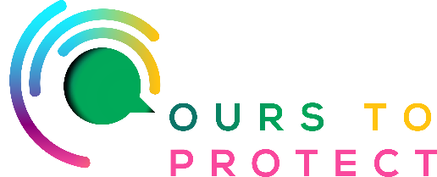

This week Ireland’s Classic Hits Radio met with Kate Doyle, who is chair of Cloth Nappy Library Ireland, and also the founder of The Nappy Market, to discuss the resources available to those who would like to switch to cloth nappies.
What resources are available?

Cloth Nappy Library is a non-profit organisation run by a national network of volunteer cloth nappy parents. We provide support, guidance, information and operate a cloth nappy loan kit library - giving families the opportunity to borrow a set of cloth nappies to try at home for a few weeks to help them make the switch to reusable.
The Libary runs a free online zoom cloth nappy workshop once per monthly - 30th Sept 11am or 25th Oct 8pm is the next two dates, booking via eventbrite. The Library also runs an excellent Facebook Chat Support Group and a Whats App Chat Support Group to guide parents making the switch to reusable (links to both resources can be found on the website)
www.clothnappylibrary.ie

The Nappy Market is an online cloth nappy retailer and resource, we provide a range of cloth nappies for every budget, including starter kits and bundles, along with a selection of preloved options to showcase the circular economy in the mainstream and make cloth affordable for every budget.
The Nappy Market was set up and is run entirely by Kate Doyle a work from home mum who decided after having her first baby, Ava, in April 2023 that there was not enough information or options for Irish parents interested in using cloth nappies. Brexit had significantly limited the purchasing options here and she felt there needed to be great choice.
www.thenappymarket.ie

Many more websites that sell cloth nappies and give their own information to help people make the switch:

www.summersweetsbaby.com

www.littlecomfort.ie

www.nappyrebels.ie

www.earthmother.ie/cloth-nappies

