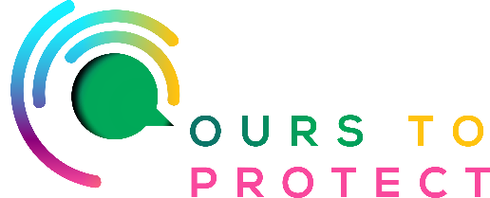
This week Ireland’s Classic Hits Radio is looking at Organic Farming.
Did you know….
- Organic farming is a sustainable production system.
- It provides the opportunity of an alternative farming system based primarily on balancing inputs and outputs in a 'closed' system.
- Increased consumer awareness of food safety issues and environmental concerns has contributed to the growth in organic farming over the last few years.
- Organic farmers can access a range of services and information from the Department of Agriculture, Food and the Marine.
- If you are an organic food consumer, the department can help connect you with producers.
- Organic farming requires:
- the consideration and application of production methods that do not damage the environment.
- a more respectful use of the countryside.
- concern for animal welfare and the production of high-quality agricultural products.

Advantages of Organic Farming….

1. No more genetically modified organisms (GMOs)
2. Soil Protection
3. Better nutrition
4. Healthy working environment around farms
5. Resistance to pests and diseases
6. Fertilizers are made naturally and on-site
7. Opportunity to grow a variety of crops
8. Climate-friendly

For More Information:

www.irishorganicassociation.ie

www.ifa.ie/organic-farming-scheme

www.farmingfornature.ie/nominees/diana-pickersgill

www.gov.ie/en/service/f5a48-agri-climate-rural-environment-scheme-acres

