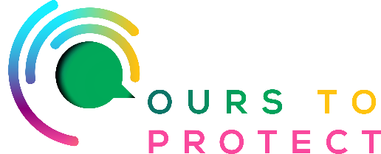
This week Ireland’s Classic Hits Radio looked at the importance of Bees for Bio-Diversity
Did you know…
- Bee’s produce six hive products, pollen, honey, beeswax, royal jelly, propolis and venom
- There are 101 native Irish bee strains, the honeybee, 21 species of bumblebee and 78 species of solitary bee
- The Irish native honey bee is called the Apis mellifera mellifera
Why are Bee’s so important?
- Bee’s help produce 1/3 of the Worlds food supply
- Help Prevent Soil Erosion
- And are key pollinators for over 90% of flowering plant species across the world
- Without bee’s humans would lose so many nutritious foods – just think of a world without apples, raspberries or tomatoes!
- The decline in bee populations across the world alerts us to the toxic track we are on
What can I do to help stop the decline in the bee population?
- Don’t mow it – let it grow! Leave some space in your garden for a wild patch with dandelions, clover and other native plants to flower. Bee’s love them!
- Plant some native bee – friendly trees. If you’re planting tree’s think about Willow, Hawthorn, Rowan or Holly. They support lots of wildlife as they blossom in springtime and a vital source of food for pollinators
- Avoid using insecticide, fungicide or herbicides in your garden. These are pollinator killers!
- Only sow wildflower seed mixes that are Irish native flowers. A lot of wildflowers you can buy have non native/ invasive species
Here’s a few websites if you want to know more !
www.pollinators.ie – the All Ireland Pollinator Plan
www.nihbs.org – the Native Irish Honey Bee Society
www.ibcp.ie – the Irish Bee conservation project

